**Project Report Template**

**1 INTRODUCTION**

* 1. **Over view:**

Retailing encompasses the business activities involved in selling goods and services to consumers for their personal,family, or household etc. A CRM product owner has requested to create two applications, one is a sales app for salesreps to use this application and store customers data, and the second applicatiom is a service app for service reps\agents to provide support to customers in dealing cases. Togenerate business on top of the customers.

* 1. **Purpose**:

Salesforce has everythingwe need to run our business from anywhere. Using standard products and features , we can manage relationship with prospects and customers,collaborate and engage with employees and partners, and store our data securely in the cloud.

1. **Problem Definition and Design Thinking**

**2.1 Empathy map:**

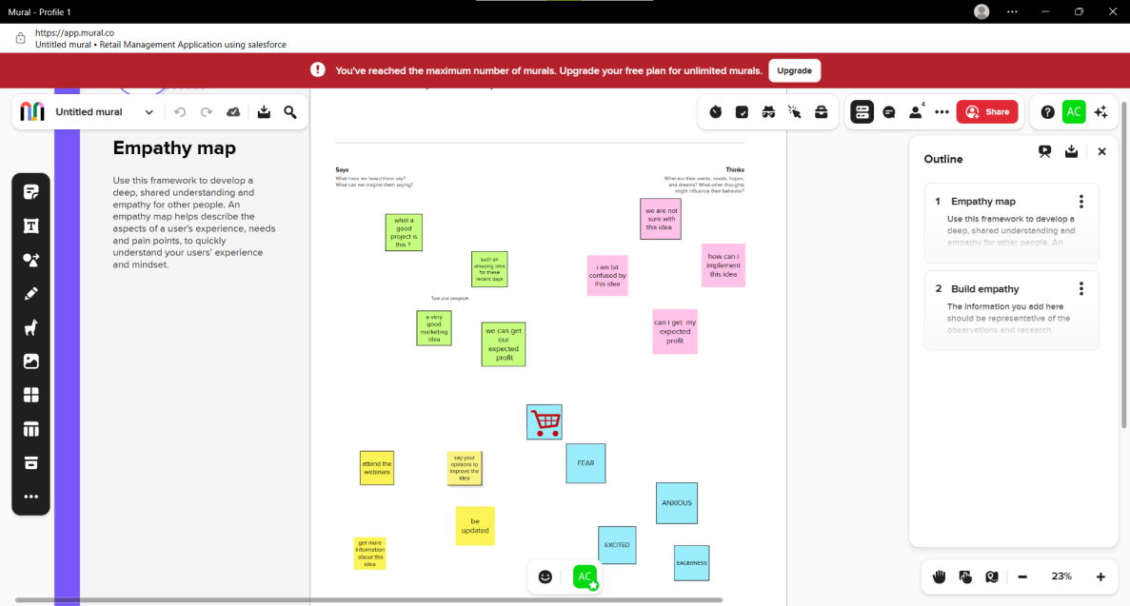

**2.2 Idea and Brain storming Map:**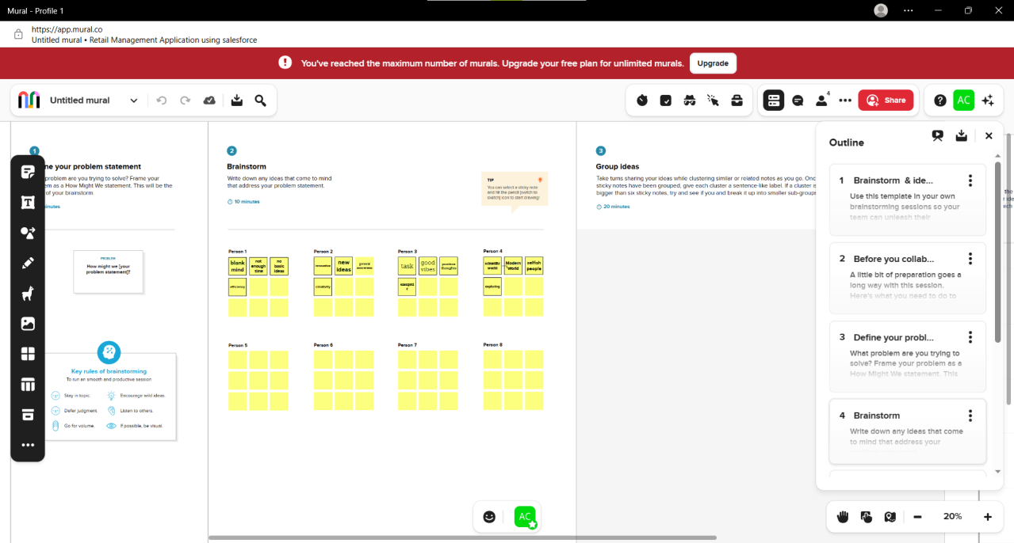

**3 RESULT**

**3.1 Data Model:**

|  |  |
| --- | --- |
| **Object Name** | **Fields in the Object** |
| **Custom object** | |  |  | | --- | --- | | **Field label** | **Data Type** | | **warehouse** | **text** | | **tracking** | **checkbox** | | **students** | **text** | | **paents** | **text** | |

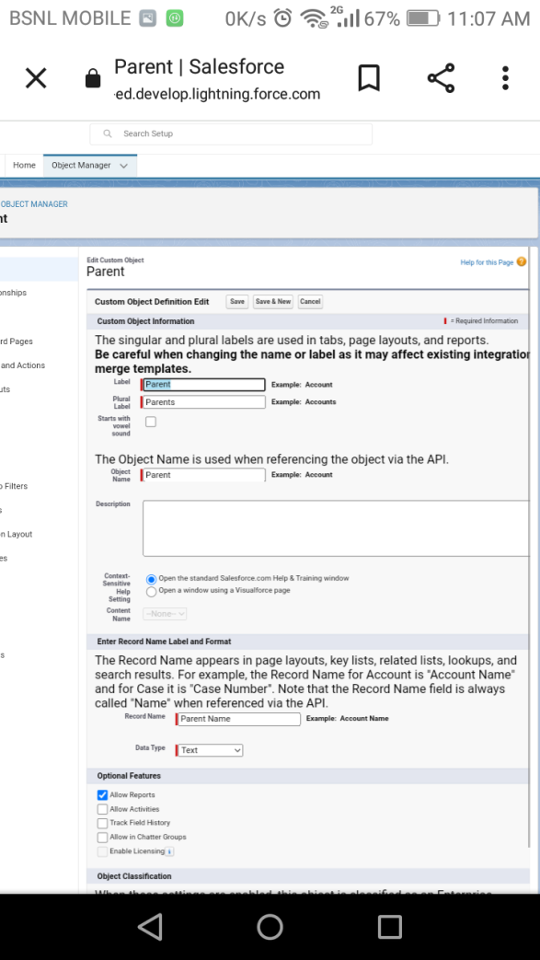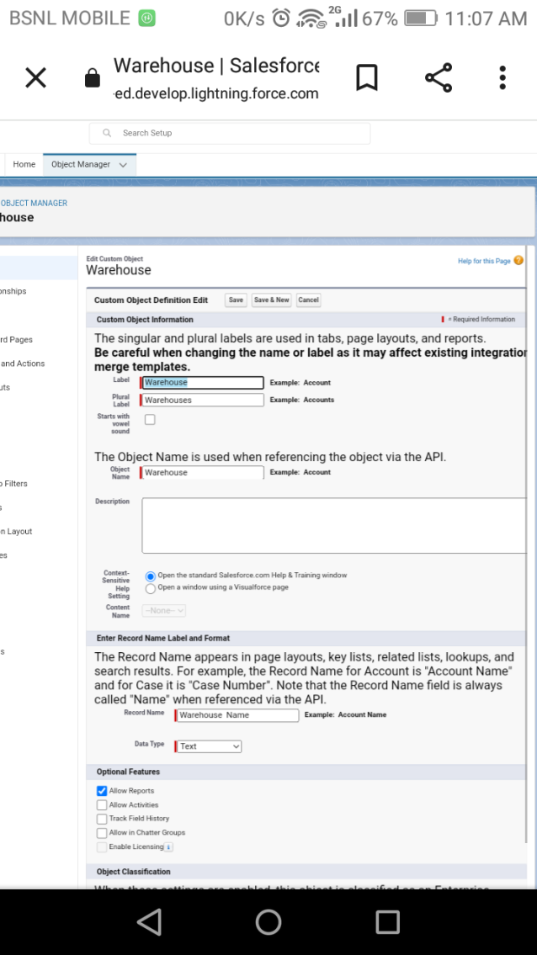

**We have created a field label parent with data type text and warehouse with data type text**

**4. Trailhead public URL:**

**Team lead: [https://trailblazer.me/id/abi12312344aab](%20%20https:/trailblazer.me/id/abi12312344aab)**

**Team member1:** **<https://trailblazer.me/id/abi7102>**

**Team member 2:****[https://trailblazer.me/id/kavys17](%20https:/trailblazer.me/id/kavys17)**

**Team member3:** **<https://trailblazer.me/id/aathv>**

**ADVANTAGES AND DISADVANTAGES:**

The biggest advantage of retail management is customer satisfaction. Efficacious planning and management prevent the situation where the customers need to be kept waiting. Even if there are a lot of people in the store, as in the case of festivities, managing the orders is the key to success. It is the task of the retail manager to ensure that the customer executives assist the customers and attend to everyone properly.

The biggest problem with retail business is that profit margins of this business is fixed which ranges from 5 to 20 percent depending upon the brand of the product which retailer is selling and also unlike wholesaler who can expand business in order to achieve economies of scale in case of retailing such thing is not possible.

**APPLICATIONS**:

* Retail management optimizes internal processes such as inventory management, offline and online storefronts, warehouse operations, payment and accounting, and human resources.
* Retail management improves overall company cohesion.
* Retail store management improves customer experience and boosts customer satisfaction.
* Retail operation management contributes to business growth.

**CONCLUSION:**

In this project, we learnt a lot in salesforce . We used mural apps and created empathy maps, brain storming ..etc., and In object manager we used many custom objects, reports, dashboards, validation rules, tabs, users…etc.,and we learnt a lot of unknown things and various ideas.

**FUTURE SCOPE:**

**The global retail management systems software market is projected to hit an overall USD 8.0 billion market size by 2028. This is majorly attributed to growing willingness of retail businesses to invest money in new business models and experiment with different retail formats.**